Lab Report No 7

Understanding of ANN functions and learning rules
Artificial Intelligence



Submitted By:
[Huzaifa Shahbaz]
[21-CE-009]
[Aqsa Shah]
[21-CE-039]
Submitted to:
Engr. Hareem Khan
Dated:
13thMay,2025
Department of Computer Engineering,
HITEC University, Taxila

Lab Task No 1:

Solution:
Brief description (3-5 lines)
ANN functions and learning rules:
Write a user defined Python function to generate the following explained non-linear activation
functions that are being used in neural networks using basic equations. Also plot them showing
grid lines, title and x-label. Use axis square.
The code
import numpy as np
import matplotlib.pyplot as plt
# Activation Functions
def sigmoid(x):
return 1.0 / (1.0 + np.exp(-x))
def tanh(x):
return np.tanh(x)
def relu(x):
return np.maximum(0, x)
def softmax(z):
e = np.exp(z - np.max(z))
return e / np.sum(e)
x = np.linspace(-10, 10, 400)
z = np.array([2.0, 1.0, 0.1, -1.0, 3.0])
softmax_probs = softmax(z)
plt.figure(figsize=(12, 10))
plt.subplot(2, 2, 1)
plt.plot(x, sigmoid(x), color='orange')
plt.title("Sigmoid Activation Function")
plt.xlabel("Input (x)")
plt.ylabel("σ(x)")
plt.grid(True)
plt.axis('square')
# Tanh Plot
plt.subplot(2, 2, 2)
plt.plot(x, tanh(x), color='green')
plt.title("Tanh Activation Function")
plt.xlabel("Input (x)")
plt.ylabel("tanh(x)")
plt.grid(True)
plt.axis('square')
# ReLU Plot
plt.subplot(2, 2, 3)
plt.plot(x, relu(x), color='blue')
plt.title("ReLU Activation Function")
plt.xlabel("Input (x)")
plt.ylabel("ReLU(x)")
plt.grid(True)
plt.axis('square')
plt.subplot(2, 2, 4)
labels = [str(val) for val in z]
plt.bar(range(len(z)), softmax_probs, color='purple')
plt.xticks(range(len(z)), labels)
plt.title("Softmax Output Probabilities")
plt.xlabel("Input Value")
plt.ylabel("Probability")
plt.grid(True, axis='y')
plt.axis('square')
plt.tight_layout()
plt.show()
The results (Screenshot)
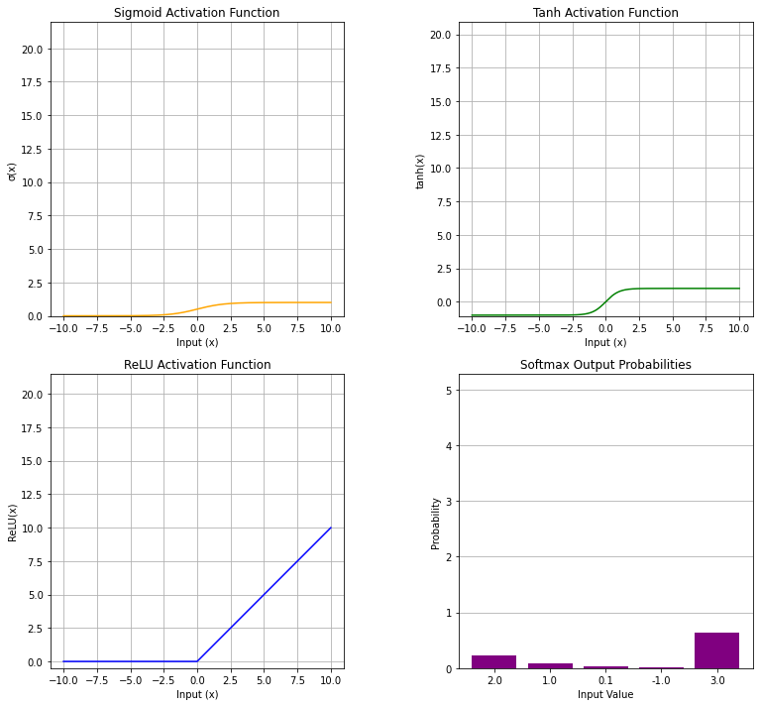

Conclusion
In conclusion,we had implemented the artifical neural network activation graphs and also we implemented the different graphs of network activation functions such as Sigmoid, Tanh, ReLU, Leaky ReLU, Parametric ReLU, ELU, SELU, Swish, GELU and SOFTMAX PROBABILITY.

